**USER MANUAL**

**USER MANUAL**

Provides a step-by-step guide on how to use the sales and employee management system properly avoiding malfunctions and application error.

**Step-by-step guide in using AU Sales and Employee Salary System**

The use of guide in using a new develop application is crucial because it acts as a comprehensive guide for users to understand the application's features, functions, and how to navigate the interface, enabling them to quickly learn and utilize the app effectively, minimizing the learning curve and improving user adoption while reducing the need for extensive training or support calls. For AU sales and employee management system here is the step-by-step guide in using it.

**1. Logging into the System**

1. Open the AU Sales and Employee Salary System on your computer.

2. Enter your **username** and **password**.  
3. Click **Login** to access the system.

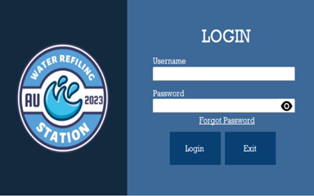

* 1. **Additional Functions on Logging into the System**

1. Click the **eye icon** to show password.  
2. Click **forgot password** to recover the account.  
3. Click **Exit** if you want to close the system.

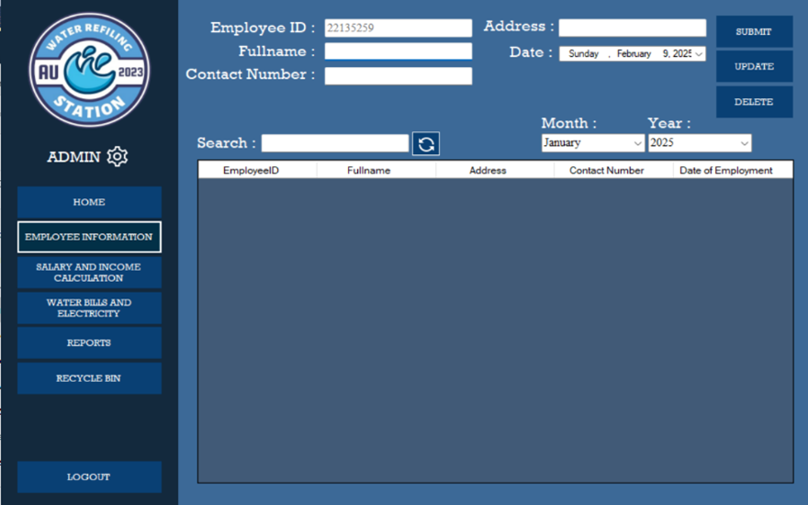

1. **Input Employee Information**1. Navigate to the **Employee Information** section.  
   2. To **Add New Employee**. Fill in the required fields.  
    • Full Name

• Contact Number

• Address

• Date (for the date of employment)

3. Click **Submit** to save the employee information.

* 1. **Updating Employee Information**1. Go to the **Employee Information.**  
     2. Below is the table where you can see the list of employees. Click the row of employee whose details need updating.

3. The employee details will show on the text fields. Make the necessary changes, and then click **Update**.  
4. The updated details of the employee will show on the table list.

* 1. **Deleting Employee Information**1. Go to the **Employee Information**.  
     2. Below is the table where you can see the list of employees. Click the row of employee whose details need to delete.

1. Click **Delete**, a **confirmation message** will show. Choose **Yes** to continue deleting the employee details and **No** if not.
   1. **Searching Employee Information**  
      1. Go to the **Employee Information.**2. Look for the label **Search**. Beside is a text field where you can input the name of the employee.  
      3. After entering the **employee’s name**, the table below will show the information of the employee.
   2. **Sorting employee information**1. Go to the **Employee Information.**2. Look for the label **Month** and **Year.** Below of these are dropdown list where you can choose from.  
      3. Select the **Month** or **Year** you want.  
      4. After selecting, the table below will show the information on employee base on selected month and year of their employment.

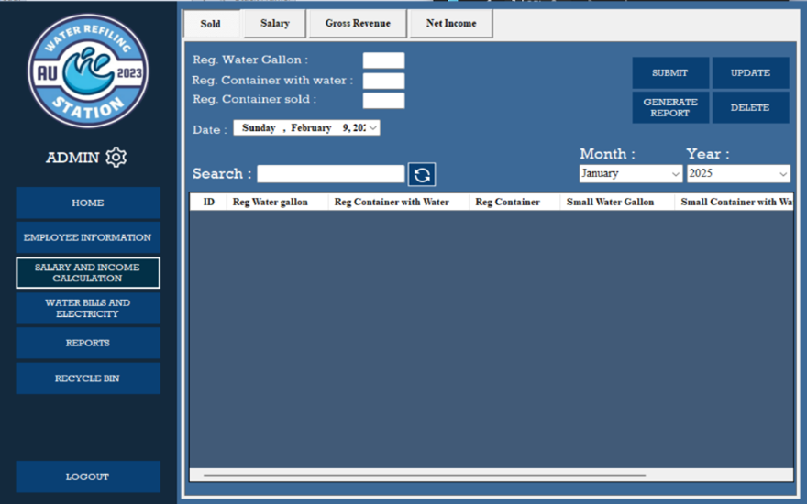

1. **Recording Sales**1. Go to **Salary and Income Computation.**  
   2. Navigate to the **Sold** section.  
   3. To **add the sales** for a day you need to fill in required fields such as.  
    - Reg. Water Gallon  
    - Reg. Container with water  
    - Reg. Container sold  
    - Date  
   4. After filling out the necessary fields. Click **Submit** to save the sales.  
   1. **Updating Sales**1. To update the Sales, Click the **row** you want to update.  
      2. Modify on what sales by choosing what you want to update and change the quantity. Choose from:  
       - Reg. Water Gallon  
       - Reg. Container with Water  
       - Reg. Container Sold
2. Click **Update** and the updated quantity of sales will computerize update and save.
   1. **Deleting Sales**1. To Delete the Sales, Click the **row** you want to delete.  
      2. Click **Delete** and a message will show asking if you really want to delete the information. Choose **Yes** if you wish to proceed and **No** if not.
   2. **Searching and sorting sales**1. Go to Salary and Income Computation  
      2. Navigate to the Sold section.  
      3. From there, you will see a Search label with a search bar.  
      4. In the search bar, you can type the quantity of sold items to search a specific detail you are looking for.  
      5. For sorting the details you need, below is the month and year. You can choose a specific month or year to sort the record of sold below.  
      6. After choosing the month or year or month and year, the record will show the record the chosen way of sorting.

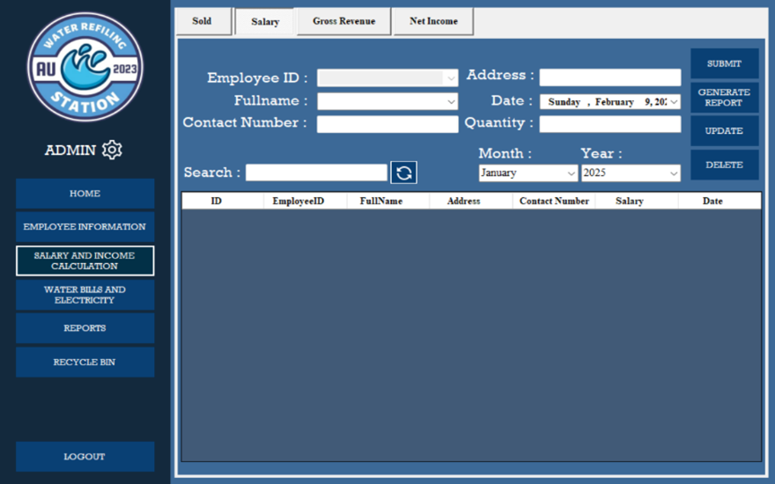

**Processing Employee Salary**

1. Go to **Salary and Income Computation**.
2. Navigate to the Salary section.
3. To compute the salary of an employee, you need to choose the employee’s name beside the label **full name**. It’s a drop-down list where you need to choose the name of the employee and it shows their details such as Employee ID, Contact Number, and Address.
4. To compute his/her salary, you need to input the **quantity of gallon** sold that day on the Quantity text field.
5. After inputting the quantity that employee sold that day. Click the **Submit** and it shows the **calculated salary** of the employee on the table below.
6. **Updating Employee Salary**1. To **update** employee salary record, click the row you want to update.  
   2. After clicking the row, you can only update the **date** and the **quantity** that the employee sold.   
   3. After editing the quantity or the date. Click **Update** and the updated information will be saved.
7. **Deleting Employee Salary**
8. To delete the employee salary record, click the row you want to delete.
9. After clicking the row, click **Delete** a message will show asking if you really want to delete the information. Choose **Yes** if you wish to proceed and **No** if not.

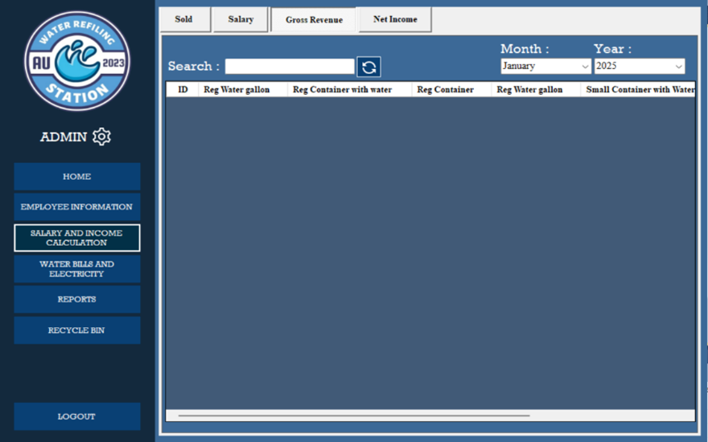

1. **Gross Revenue** Record  
   1. Go to **Salary and Income Computation.**  
   2. Navigate to the Gross **Revenue** section.  
   3. In the **Gross Revenue** section, you will see the list of the sales of the shop.   
   4. Below the table, you will see a scroll bar. All the records of sales will show and at the end of row, you will see the Gross Revenue for that day.
   1. **Gross Revenue** Record Searching and Sorting  
      1. Go to **Salary and Income Computation**  
      2. Navigate to **Gross Revenue** section  
      3. In the **Gross Revenue** section, you will see Search, Month, and Year labels.  
      4. To **Search**, just input an amount to show the row with the amount you are looking for.  
      5. To **Sort** the record, there is a drop-down list for **Month** and **Year**. Choose a year or month or month and year and it will computerized show all the details from your chosen Month or year or Month and Year.

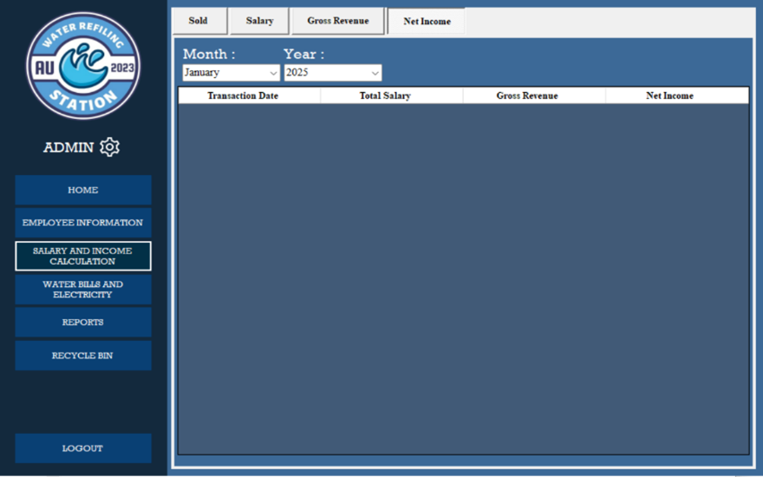

1. **Net Income Record**1.To access the **Net Income Record,** Go to **Salary and Income Calculation.**2. Navigate to the Net **Income** section.  
   3. On the net income section, you will see the record of the income generated.
   1. **Sorting Net Income Record**1. To access the **Net Income Record,** Go to **Salary and Income Calculation.**2. Navigate to the Net **Income** section.  
      3. You can sort the record of net income by choosing a month or a year or month and year in a drop-down list.  
      4. After selecting on what way do you want to sort the record, it will computerized sort and show the record with the chosen format.

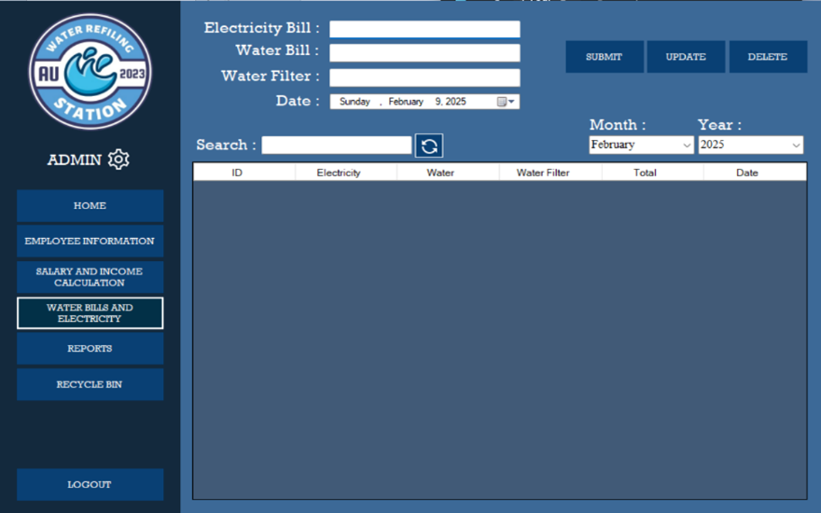

1. **Recording Utility Bills**1. Go to **Water and Electricity**.  
   2. To record a bill. Fill in the required fields.  
    - Electricity Bill  
    - Water Bill  
    - Water Filter  
    - Date  
   3. Click **Submit** to save the expenses for utility bills.
   1. **Updating records of Utility Bills**1. Go to **Water and Electricity**.2. To update utility bills, click the **row of data.**  
      3. Modify the changes you want to update.  
      4. After modifying, click **Update** and the modified changes will be saved and update
   2. **Deleting records of Utility Bills**1. Go to **Water and Electricity**.2. To update utility bills, click the **row of data.**
2. Modify the changes you want to update.
3. After modifying, click **Update** and the modified changes will be saved and update.
   1. **Searching and Sorting Utility Bills record**1. Go to **Water and Electricity**.2. To **search** a specific utility bill, there is a label Search and beside it is a Search text field where you can type in a specified amount you are looking for**.**  
      3. After typing the specified amount you are looking for, the list below will show all the records that are the same as what you are searching for.  
      5. To **Sort** the bills record, you can choose from a drop-down list under the Month and Year. You can sort by month, year, or by month and year.  
      6. After choosing a way to sort the records, it will computerized show the records.

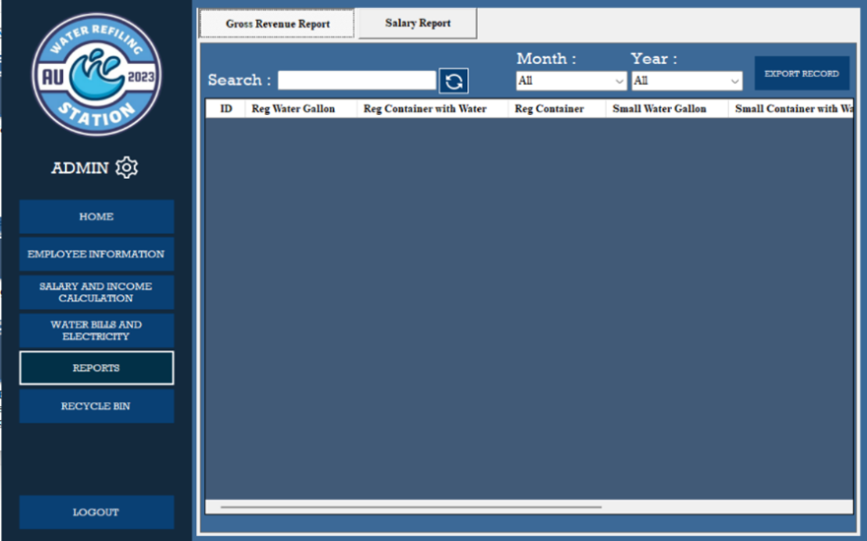

1. **Generating Gross Revenue Reports**
2. Go to **Salary and Income Calculations**
3. Navigate to **Sold** section.
4. Go to records below the search label.
5. Select **at least two or more rows** using the Shift key or Ctrl key.
6. After selecting the rows, Click **Generate Report**.
7. A message will show asking if you want to generate a report. Click **Yes** to proceed with creating the report and **No** if not.
8. After clicking yes, Go to **Reports.**
9. Navigate to **Gross Revenue Report.**
10. You can now see the records of the Gross Revenue Report. Use the scroll bar below to see all the content of the records.
    1. **Searching and Sorting Gross Revenue Reports**1. Go to **Reports**  
       2. Navigate to the Gross **Revenue Reports** section.3. Beside **Search** label is a text field where you can enter what data you are looking for.  
       4. After entering the data you are looking for, the records below will show the data that match from the data you enter on the search text field.  
       5. To sort records, you can use the drop-down list under the **Month** and **Year** label. Form the drop-down list, you can choose a month and a year or both to sort the records.  
       6. After choosing on how you want to sort the records, it will computerized show the sorted that match to the month, year, or both you selected.
    2. **Downloading soft copy of Gross Revenue Reports**1. Go to **Reports.**  
       2. Navigate to the Gross **Revenue Reports** section.

3. On the records table, **select rows** you want to generate a soft copy report.  
4. After selecting, click the **Export Record**.  
5**. Choose a folder** on your file manager you want to save the report.  
6. Click **Save** and an excel file of the reports is save on your **computer’s file manager.**

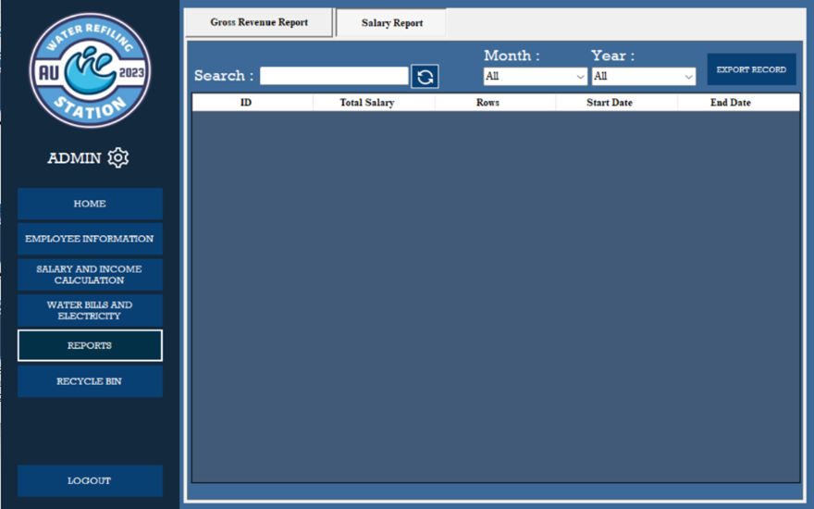

1. **Generating Salary Reports**1. Go to **Salary and Income Calculations.**2. Navigate to **Salary** section.  
   3. Go to records below the search label.  
   4. Select **at least two or more rows** using the Shift key or Ctrl key.  
   5. After selecting the rows, Click **Generate Report**.  
   6. A message will show asking if you want to generate a report. Click **Yes** to proceed with creating the report and **No** if not.7. After clicking yes, Go to **Reports.**  
   8. Navigate to **Salary Report.**  
   9. You can now see the records of salary Report.
   1. **Searching and Sorting Salary Reports**1. Go to **Reports.**  
      2. Navigate to **Salary Reports** section**.**3. Beside **Search** label is a text field where you can enter what data you are looking.  
      4. After entering the data you are looking for, the records below will show the data that match from the data you enter on the search text field.
2. To sort records, you can use the drop-down list under the **Month** and **Year** label. Form the drop-down list, you can choose a month and a year or both to sort the records.
3. After choosing on how you want to sort the records, it will computerized show the sorted that match to the month, year, or both you selected.
   1. **Downloading Soft Copy of Salary Reports**1. Go to **Reports.**  
      2. Navigate to the Salary **Reports** section.

3. On the records table, **select rows** you want to generate a soft copy report.  
4. After selecting, click the **Export Record**.  
5**. Choose a folder** on your file manager you want to save the report.  
6. Click **Save** and an excel file of the reports is save on your **computer’s file manager.**

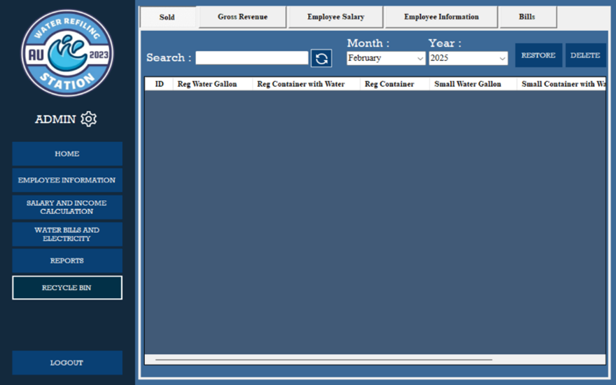

1. **Recovering a Deleted Information**1. Go to the Recycle **Bin.**  
   2. Navigate to the section **where you want to restore deleted information**.

3. On the records table, **select rows** you want to recover.  
4. After selecting, click the **Restore**.

1. A message will show saying that the selected row successfully recovers.
2. Go to the section where you recovered the information and it will show the recovered data. For example, you restore data from the sold section in the recycle bin. The restored data will show at the sold section under the salary and income computation.

10.1 **Permanently Deleting an information**

1. Go to the Recycle **Bin.**
2. Navigate to the section **where you want to permanently delete the information**.
3. On the records table, **select rows** you want to permanently delete.
4. After selecting, click the **Delete**.
5. A warning message will show saying that you are sure you want to delete the data. Click **Yes** if you want to proceed and **No** if not.

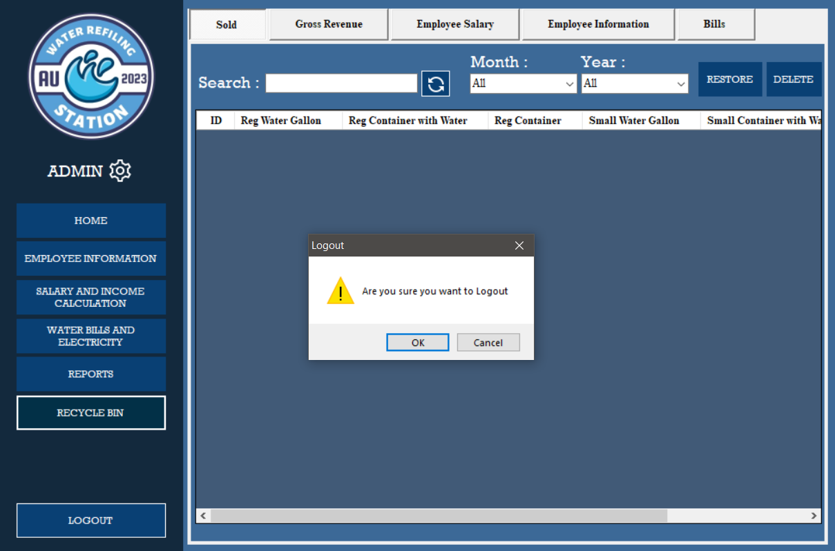

1. **Logging out from the System**  
   1. On the option bar, click **Log Out**.  
   2. A message will show asking if you are sure to log out.  
   3. Click **Yes** to log out and **No** if not.
2. **Closing the application**1. After logging out, the log in form will show.  
   2. Click **Exit**, a message will pop up. Click **OK** if you want to proceed to exit the application and **cancel** if not.